Actors Fund Arts Center
Brooklyn, New York
November 5, 2016 afternoon

Neville Dance Theatre: Exposed
- November 12, 2016

Neville Dance Theatre
Exposed:
Blessed, Exposed
Jerry Hochman

A year ago I reviewed the 10th anniversary performance of Neville Dance Theatre, and marveled at how accomplished companies like this can be.

A faculty ballet instructor at the Ailey School in Manhattan and Covenant Ballet Theatre in Brooklyn, Brenda R. Neville founded NDT in 2006. The company, which appears to have a relatively stable nucleus of dancers, performs at a variety of city locations.
This year, Neville, the company’s Artistic Director and Choreographer, presented two works titled “Blessed” and “Exposed,” both of which were world premieres.

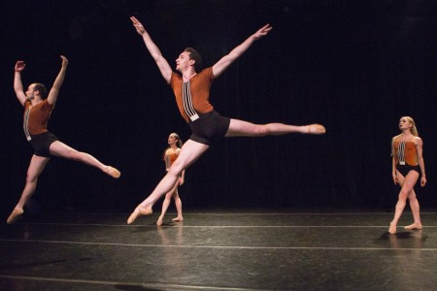
Neville Dance Theatre dancers (l-r) John Raffles Durbin,
Kaylee Tong, Hunter Mikles, and Tanya Lynn Trombly
in Brenda R. Neville’s “Blessed”
Photo Yi-Chun Wu

Blessed, choreographed to Karl Jenkins’s achingly beautiful Benedictus, arranged and performed by 2Cellos, is a simple piece that does what it intends to do – create an ambiance of ethereality and faith, does it well, and then ends. The music, part of a larger anti-war themed composition (called The Armed Man, and subtitled A Mass for Peace) that Jenkins created in 1999 in response to the conflict in Kosovo (it premiered in 2000), follows the conflict movements and celebrates the triumph of peace. The music washes over the listener as if it were a star-filled sky into which you soar in eternal harmony with the universe, and even if Neville’s choreography had simply done no harm to the composition, the theatrical experience would have been uplifting. But her choreography, for John Raffles Durbin and Kaylee Tang, and Trombly and Mikles, complements it. In my notes, I wrote the word “sweet” many times as I watched Blessed unfold, and perhaps Neville and her dancers’ finest accomplishment is that the piece is sweet without being saccharine. I liked Blessed a lot.

Exposed, the evening’s signature piece, was well-done and includes a variety of movement and staging that maintain visual interest throughout.

The piece, which is loosely divided into three segments, begins by showing dancers posing and mugging for photos taken by other dancers who hold hand-held lights. The objects of attention appear to invite and relish the attention – and with rare exception, that sense doesn’t fade or change as the piece progresses. There are indeed occasional examples of a photographed “object” trying to shield him/herself from the “camera” or looking uncomfortable with the attention, but the “invasion of privacy” by the dancer-paparazzi continues nevertheless, and is generally not played as unwelcome. There’s nothing that appears as anything resembling a clarion call for action. The dancers – the entire company (including, in addition to those already mentioned, Jess Guerrero, and Matthew Lynady), both those who are the photographed “objects” and those who hold and maneuver the lighting, do a fine job with it, and the piece choreographically is not without merit as an abstract cautionary tale.

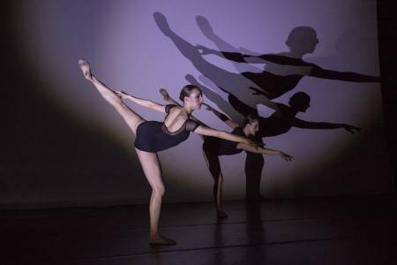

Neville Dance Theatre dancers
Dona Wiley and Alexis Borth
in Brenda R. Neville’s “Exposed”
Photo Yi-Chun Wu

The dances on Saturday’s program featured competent dancers performing entertaining choreography before a full and attentive audience. Overall, the program is another example of the quality of dance presented in the city’s performance nooks and crannies on a regular basis throughout the year. They’re not competition for the city’s big guns, but they fill a void, and are well worth seeing.

